**Lab 2: Create Your VPC**

Paul Polsinelli

Information Technology, Arizona State University

IFT 472: Managing the Cloud

Professor Neff

Aug 30th, 2020

**Lab 2: Create Your VPC**

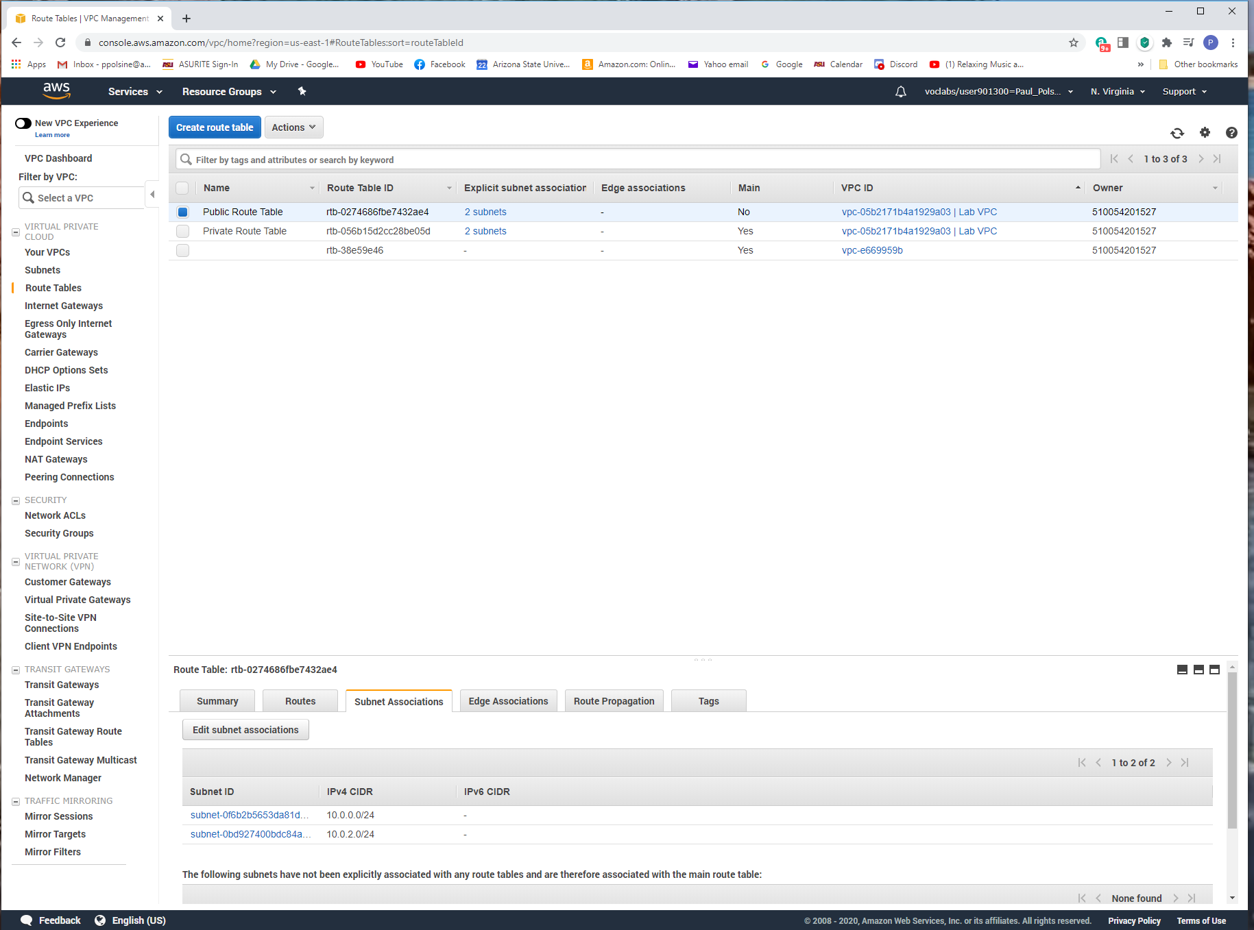

*Figure 1*. Screenshot of both subnets associated with your VPC.

**Lab 2: Create Your VPC**

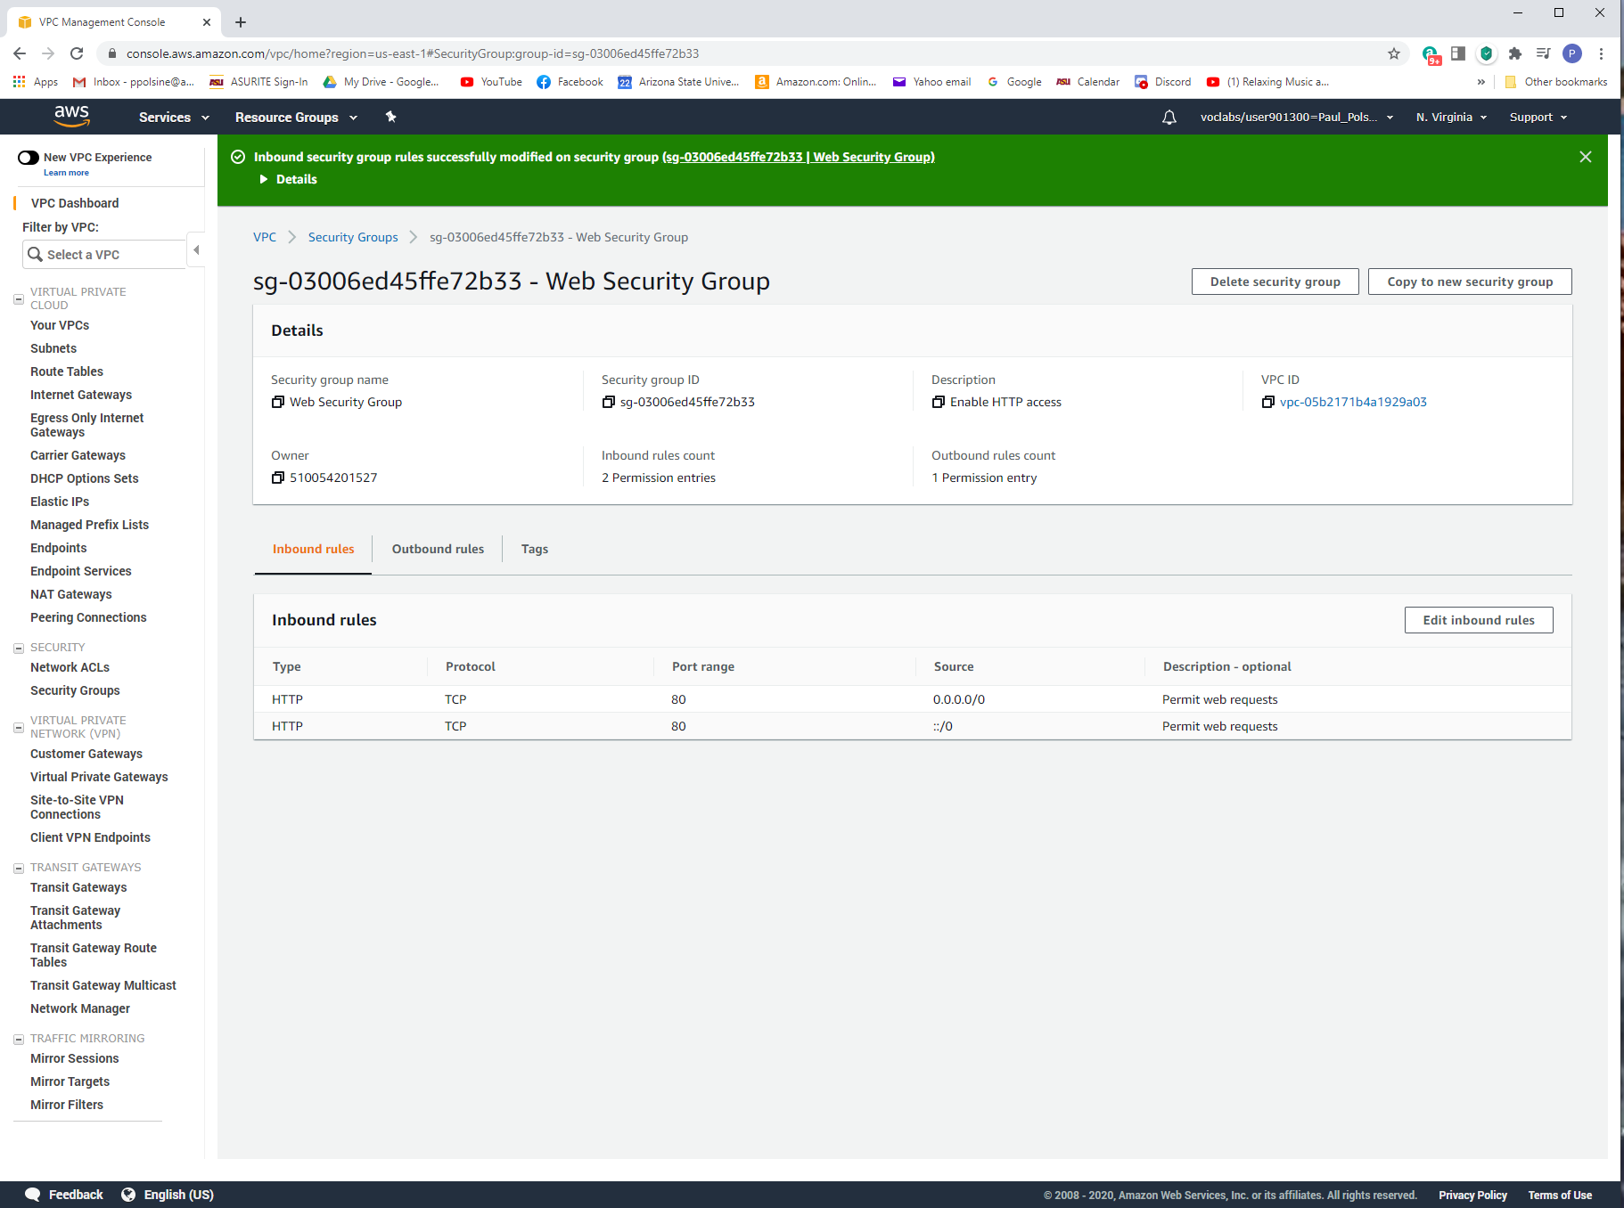

*Figure 2.* Screenshot of the security group rules.

**Lab 2: Create Your VPC**

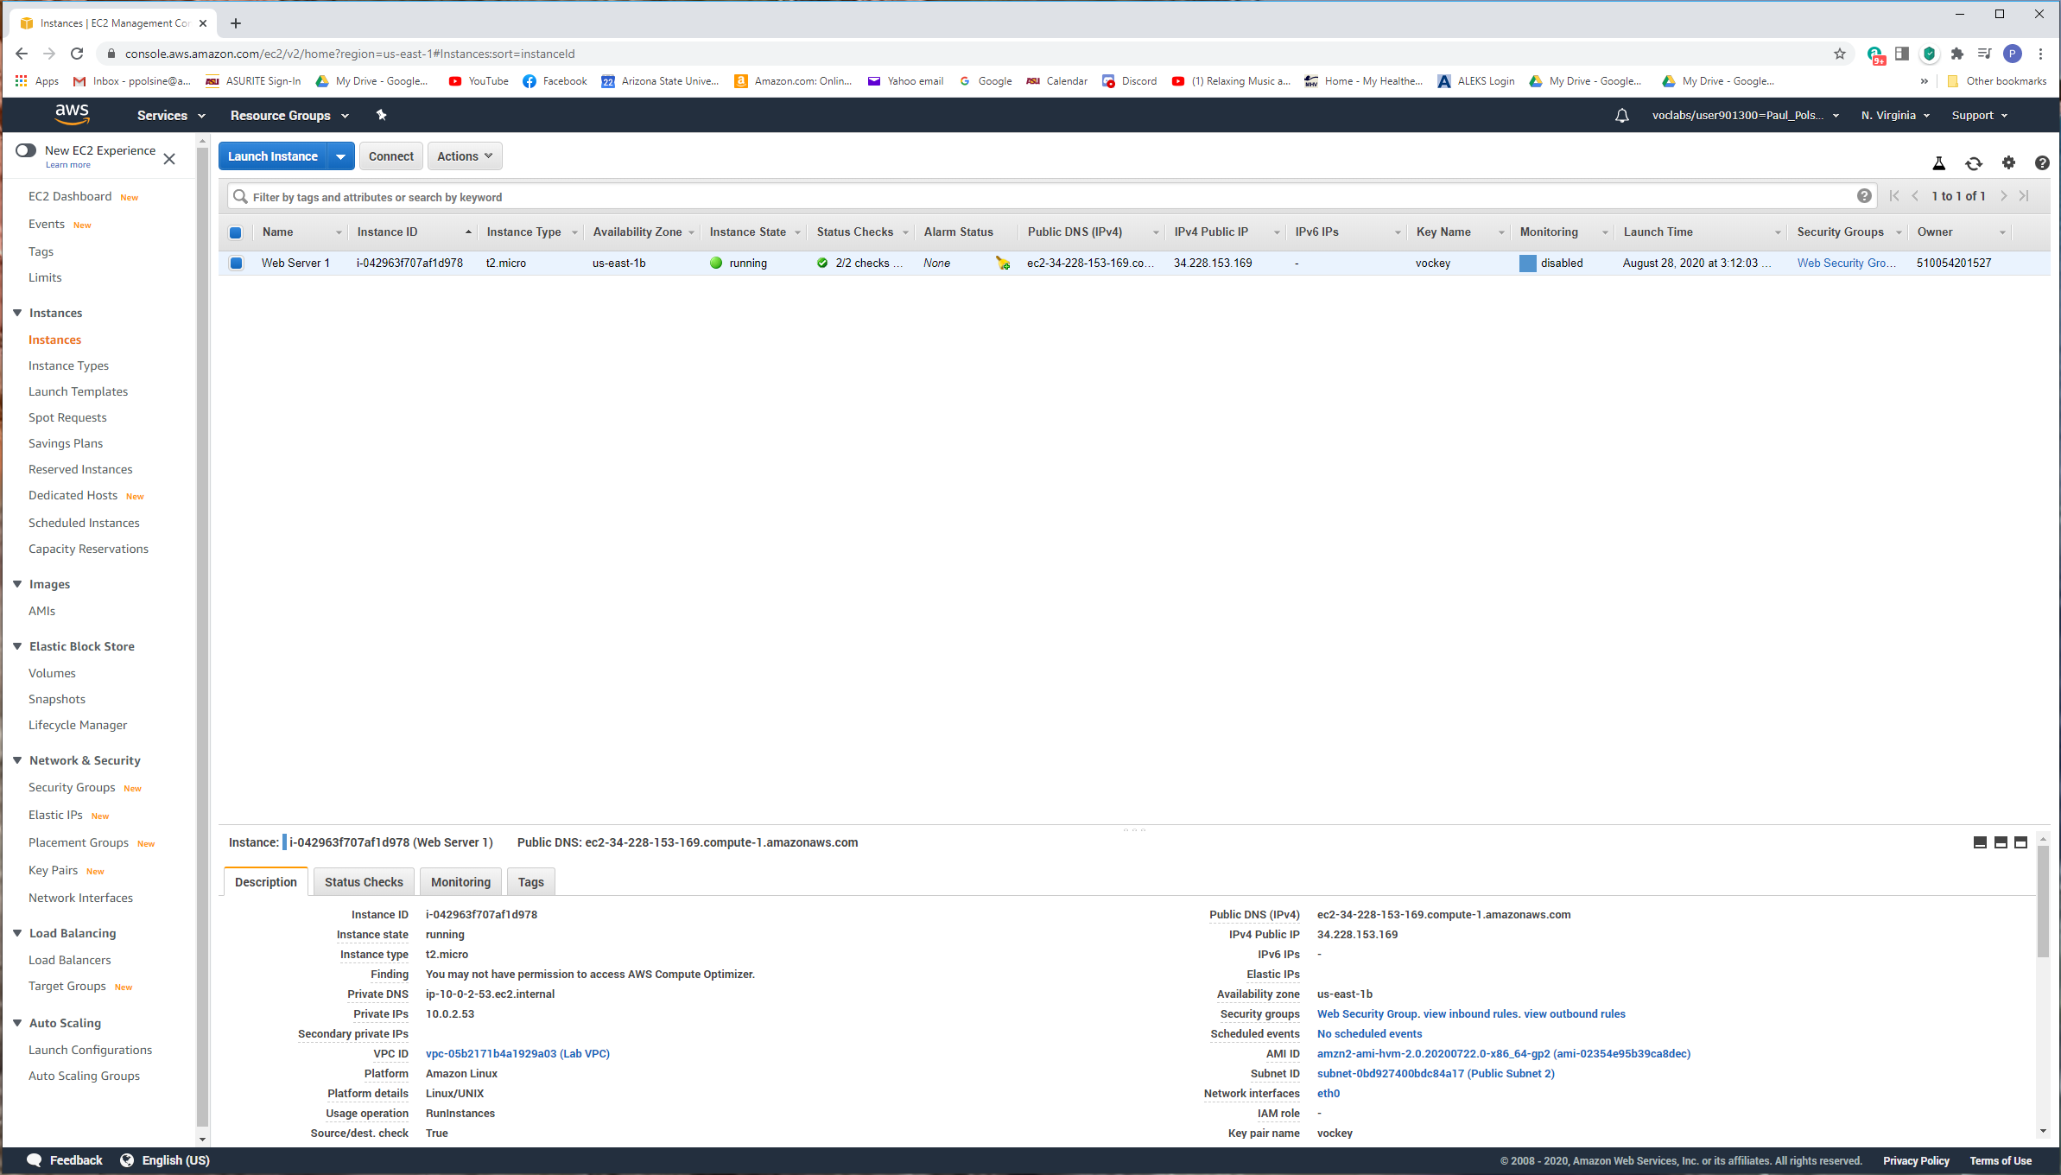

*Figure 3.* Screenshot including the details of the webserver.

**Lab 2: Create Your VPC**

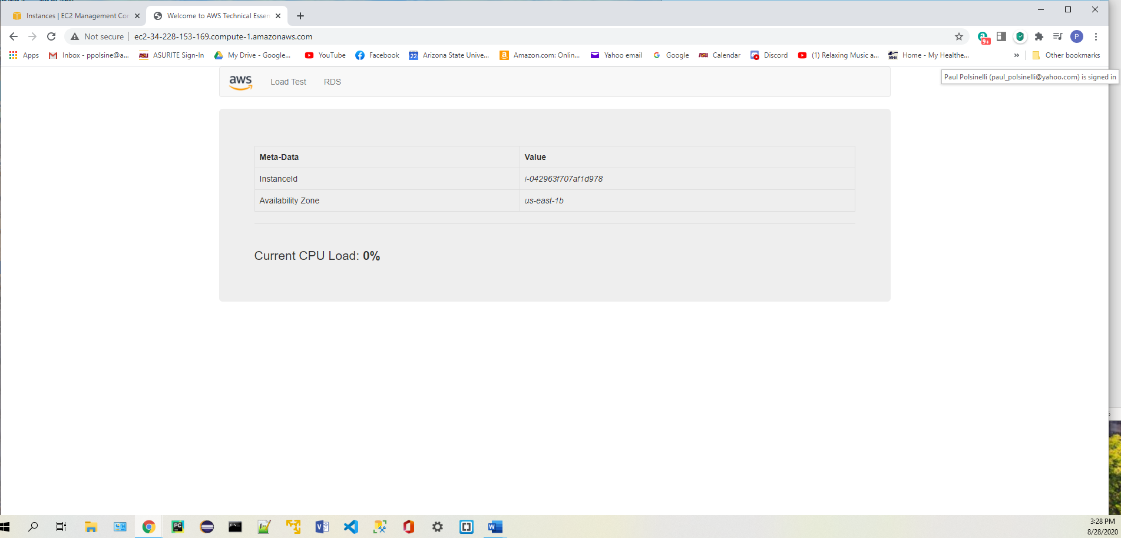

*Figure 4.* Screenshot of accessing the webserver through a web browser.